|  |
| --- |
| *This design document is intended for the use of the VR&R development team. The document will continue to be updated throughout the project’s development.* |

Tidy Trainers

Departure Cleanings for One-Bedroom Deluxe Units

**Collaborative Groups**



|  |
| --- |
| *Items listed within the Table of Contents are interactable while viewed in a web browser.*  *Click on the desired item to navigate to that section.* |

# Table of Contents

**Table of Contents** **1**

**► I. Team Overview** **3**

Course Details 3

Team Roster 4

Credits 5

Contact Information 6

Team Expectations 7

Professional Conduct 7

Communication Expectations 10

Deliverables Expectations 11

Time-Related Data 12

Milestones 12

Calendar 13

Hourly Rates 18

**► II. Project Overview** **19**

Core Design Concept 19

Synopsis 19

Design Specifications 19

Technical Specifications 20

Work Specifications 21

Visual Elements - 3D Assets: 21

Lighting/Texturing: 21

Visual Effects: 21

Animation and Camera: 22

Visual Elements - 2D Assets: 22

Behaviors and Functionality: 23

Audio Engineering: 23

Client Overview 24

Client Q&A 25

General 25

VR Specific Details 27

Environment 28

UI/UX 28

Updates & Deliverables 29

Resources 29

Legal & Other 30

Aesthetic References 31

Photo References 31

Floor Plans 32

**► III. Naming Conventions & Project Terminology** **34**

Deliverables Naming Conventions 34

Visual Assets 34

Programming Assets 35

Audio Assets 36

►Audio files 36

Project Terminology 37

**► IV. Gameplay and Mechanics** **39**

Gameplay Objectives 39

Mechanics 39

VR Controllers & Unity Specifications 39

Our Commands: Inputs & Controls 41

Economy & Rewards System 42

Game Options & Data 42

Bonus Content: Secret Behaviors and Easter Eggs 43

**► V. Game Art & Visual 3D Assets** **44**

3D Aesthetic 44

Reference Sources (Links) 44

**► VI. User Interface & User Experience** **46**

UI Aesthetic 46

User Experience (UX) 46

Functionality 46

**► VII. Audio** **47**

Sound Design & Intentions 47

Sound Libraries & Resources 47

# ► I. Team Overview

## Course Details

GA409 Game Pre-Production Team | Spring 2018

GA412 Game Production Team | Summer 2018

GA413 Game Post-Production Team | Fall 2018

Instructor: Nikki Dunsire

Schedule: RM 308 | Mondays 1:00pm - 5:00pm

In this course, students will work collaboratively to finish an original interactive application. Students will focus on a specific area of expertise but will be exposed to all facets of the production process.

Overall goal over the course of 3-4 terms: The creation of assets and elements of a interactive application, including design documentation, level designs, 3D art and models, and UI/UX design in a production team environment.

This class is a collaborative group effort that is intended to simulate a professional studio environment. Consistent communication and adherence to class deadlines is crucial. Students who fail to perform at a professional level will be dropped from the course.

Prerequisite: GA415, Jr. Level & Instructor Approval

Additional Course Outcomes: Upon successful completion of this course, the student should have developed skills in critical thinking, creative problem solving, team building, recognition of appropriate conduct in a professional environment, and a heightened sense of time management

## 

## Team Roster

|  |
| --- |
| *The* ***Team Roster*** *lists team members once. It is prioritized by leadership roles, main roles, and then organized alphabetically by first name. This list was enclosed in the client contract.* |

**Executive Producers:**

Nikki Dunsire

Anthony Pires

**Co-Producers:**

Thea Moon

Kailani Piñon

**Lead Visual Artist:**

Toby Wolfe

**Lead Audio Engineer:**

Haneen Bakhashwain

**Visual Artists:**

Annie Johnson

Chris Snegireff

Dominique Fitowski

Jerryd Perry

Navarre Packham

Patron Clark

**Lead Programmer:**

Stephen Ouellette

**Programmers:**

Aziz Alkhelaiwi

Damon Smith

Dasha Moyer

Richard Paskvan

|  |
| --- |
| ***Contact information is available on page 6.*** ***Click to navigate to Contacts******.*** |

## 

### Credits

|  |
| --- |
| *The*  ***Credits*** *lists team members according to all their involvement in varying areas of the project. Additionally, it lists regular consultants and is organized alphabetically by first name.* |

**Executive Producers:**

Nikki Dunsire

Anthony Pires

**Co-Producers:**

Thea Moon

Kailani Piñon

**Lead Visual Artist (3D):**

Toby Wolfe

**2nd Visual Artist (3D):**

Dominique Fitowski

**Lead Visual Artist (2D UI Sprites):**

Thea Moon

**Lead Audio Engineer:**

Haneen Bakhashwain

**Lead Programmer:**

Stephen Ouellette

**2nd Programmer:**

Kailani Piñon

**Visual Artists (3D):**

Annie Johnson

Aziz Alkhelaiwi

Christ Snegireff

Dominique Fitowski

Jerryd Perry

Navarre Packham

Patron Clark

Toby Wolfe

**Visual Artists (2D Textures):**

Toby Wolfe

**Visual Artists (2D UI Sprites):**

Kailani Piñon

Patron Clark

Thea Moon

**Audio Engineers:**

Haneen Bakhashwain

Jerryd Perry

Richard Paskvan

**Programming - Inputs and Controls:**

Stephen Ouellette

Damon Smith

**Programming - Shaders & Particle Systems:**

Aziz Alkhelaiwi

Dasha Moyer

Stephen Ouellette

**Programming - User Interface & User Experience:**

Kailani Piñon

**Programming - Audio Functionality:**

Richard Paskvan

**Westgate Representatives & Consultants:**

Alan McCormack

Jorge Rodriguez

Victor Arguelles

**Playtesters & Additional Consultants:**

Grimm Gillespie

Nadya Surjoko

Max Bennett

## 

### Contact Information

|  |
| --- |
| *Students are listed in alphabetical order by first name. The provided data is listed with the intention of being used for production communication. Do not abuse contact information.* |

**Trello**: <https://trello.com/b/Hnkk9Xmb>

**Discord**: <https://discord.gg/xWg7AQk>

|  |  |  |  |
| --- | --- | --- | --- |
| **Member (15/15)** | **E-mail @stu.aii.edu** | **Trello** | **Discord** |
| **Annie Johnson** | johnsanne | johnsanne | Annie |
| **Aziz Alkhelaiwi** | M4d | azizalkhelaiwi1 | hoeziz |
| **Chris Snegireff** | chris.snegireff | chris25590478 | Snergelton |
| **Damon Smith** | smithdam1 | smithdamon | smithDamon |
| **Dasha Moyer** | dashamoyer | dashamoyer | Dasha |
| **Dominique Fitowski** | domino32 | dominique826 | domino32 |
| **Haneen Bakhashwain** | HBakha | hbakba | Haneen |
| **Jerryd Perry** | JerrydPerry | jerrydperry | Jerryd |
| **Kailani Piñon** | KailaniPinon | kailanipinon | Kailani |
| **Navarre Packham** | npackham | navarrepackham | Erravan |
| **Patron Derbysher** | PatronPPatron | guardian_patron | Guardian Patron |
| **Richard Paskvan** | rapaskvan | richardpaskvan | Rich Paskvan |
| **Stephen Ouellette** | SCOOBZ1234 | stephenouellette | Stephen |
| **Thea Moon** | alethearia | alethearia | Thea |
| **Toby Wolfe** | Epik | wolfe170 | Toby |

|  |
| --- |
| *GitHub information is located under* ***Deliverables Expectations*** *(page 7) and* ***Technical Specifications****(page 16). A link to our GitHub guide is available* [***here***](https://docs.google.com/presentation/d/1fipz3j-UHvIYCW886oUE3-G-DjroWMilVsgRPu7Cg4Y/edit?usp=sharing)*.* |

## Team Expectations

### Professional Conduct

|  |
| --- |
| *Most of the responsibilities listed below are also available on the Pre-Production course syllabus. You can access the Pre-Production syllabus using this link:* [***click here***](https://github.com/scoobz1234/AIProduction/blob/master/Class%20Documents/GA409_GamePre-Production.pdf)*.* |

Team members are responsible for the following behaviors:

1. **PUNCTUALITY**
   1. Be present before production sessions begin.
   2. Tardiness is unacceptable and will be reflected in your overall grade.
   3. Notify the team ahead of time regarding possible tardiness or absence.
2. **ATTENDANCE**
   1. If you miss a class, you’re responsible for talking to teammates to become caught up.
   2. If you’re sick, please do not come to class and infect others. Notify us and rest up!
3. **DEADLINES**
   1. Meet deadlines to the best of your abilities. Late work is not acceptable.
   2. Every component holds importance in the project, thus strive to complete deliverables in a timely manner.
4. **RESPONSIBILITY & ACCOUNTABILITY**
   1. Manage your time wisely.
   2. Ask questions when necessary.
   3. Back up your work.
   4. You are responsible for the things you have control over. Do not focus on outside distractions. As they say, ‘check drama and unrelated distractions at the door’. Your teammates are relying on you to stay focused.
5. **PROACTIVE LEARNING**
   1. Utilize all available resources (ex: Google, online tutorials, the library, each other, etc)
   2. Help peers as necessary in a healthy learning space.
   3. Be encouraging to your team members. Everyone benefits from a supportive environment.
6. **COMMUNICATION**
   1. Attempt to be transparent about the state of your deliverables (or other project matters) throughout the project’s development.
   2. Use the established communication channels to effectively discuss the project.
   3. Be honest, direct, constructive, calm, respectful, and professional.
   4. Avoid being disrespectful, sarcastic, condescending, aggressive, or personal attacks.
   5. Avoid drama, but resolve harmful incidents if they occur. Preferably resolve them in class.
7. **PARTICIPATION & SEATING ARRANGEMENT**
   1. Participate during in-class discussions as much as you can.
   2. Don’t self-isolate or wander around the halls.
   3. Be present and focused.
   4. Work within the designated seating arrangement in order to improve production efforts and make communication easier for the team. ***(Illustrated Below)***
8. **CONTENT OWNERSHIP**
   1. Content and ideas discussed in class as part of the production, are owned by the class as a whole and ultimately the media department and end client.
   2. No one person may claim sole ownership over ideas and content and/or prohibit the class from its use.
   3. If you have any ideas that you think you might be too personally connected to you that you are unwilling to see altered in any way, you may want to save those for personal projects. Otherwise, share away!
   4. Don’t be afraid to put yourself out there and be open minded…many of the best productions have come from ideas that morphed into something completely different than the original pitch, as a result of creative brainstorming and diverse influences. Collaboration also makes for more well-rounded portfolio pieces.
9. **RECEPTIVENESS TO FEEDBACK & CRITIQUE**
   1. You’ll be expected to take notes during moments of critique.
   2. Do no disparage your own work.
   3. Excuses will not be tolerated.
   4. Ask questions. Don’t assume.
10. **FEEDBACK & CONTENT DECISION MAKING**
    1. All decisions regarding content direction, storyline and/or asset adjustments will be made each week at the beginning of class during group check-ins via team vote.
    2. In the event of a tie, the instructor will act as the ‘tie-breaker’. Once votes are complete, they are considered final unless at least 70% of the class feels it should be put up to a re-vote at a later time.
    3. While producing a product for an end client, all revisions and final decision making regarding the project are driven by them. We can and will make suggestions, however they have the right to make the final call on any component of the project.
11. **PROFESSIONAL CONDUCT:**
12. I will be factoring professional conduct into your overall grade. You are expected to conduct yourselves in a way the mimics a professional environment. This includes all of the bullet points above.
13. As a rule of thumb - if you wouldn’t do something on a job, you shouldn’t do it in the classroom. This includes conduct toward other classmates and instructors alike.
14. **Networking**: In each of your courses you are networking whether you realize it or not. Your instructors and classmates could become future coworkers. They could be instrumental in job recommendations.
15. If you are not submitting homework, coming in late, not showing up to class, being unreceptive to feedback, disrupting class, digging your feet in and being unwilling to compromise or generally acting in an uncoachable manner… those things are registered consciously and subconsciously by those in the room with you. The other side of that is equally true. People recognize those willing to help others, being receptive to feedback, openness to collaboration, flexibility, effort, commitment to finding success and self reflection (rather than deflection) in moments of failure. I want to encourage you all to fall into the latter of these categories.
16. **COME TO CLASS PREPARED**
    1. bring course-related materials (notes, external drives, projects, assignments)
17. **HAVE FUN**
    1. This is the best one! You are going into a really cool field!! This is as close to the real thing as you can get in a school environment.
    2. Get excited about the materials you create! Try to come out of this course with portfolio material!

### 

### Communication Expectations

Team members will:

1. **BE RESPONSIVE TO COMMUNICATION EFFORTS**
   1. Try your best to answer messages as they pertain to you in a timely manner.
   2. Ignoring specific efforts to reach out to you (especially zero acknowledgement after a 7-day period) is generally frowned upon.
2. **NOTIFY THE TEAM REGARDING ABNORMAL SCHEDULES**
   1. If you’re aware that you’ll be late or absent, let the team know.
   2. The sooner the notice, the better.
3. **ATTEND DESIGNATED TEXT/VOICE CHATS AS NECESSARY**
   1. If you’re scheduled to participate in a project text/voice chat, be sure to attend. If you are unable to, notify the appropriate members as soon as possible.
4. **UPDATE TRELLO CARDS**
   1. Effectively communicate the status of your assignments by managing your designated Trello cards.
5. **FILL OUT WEEKLY WORK LOGS**
   1. Effectively communicate the hours you are investing towards the project each week.
   2. Record time from class sessions, project discussions (outside of class), project research and development (outside of class), or any size-able working durations that pertain to the project.
   3. Submitted data will be primarily recorded by Thea and redistributed to individuals at the end of the quarter.
   4. Time Tracking Form available here: <https://goo.gl/forms/nsDukUyKzjAxNyTP2>

### 

### Deliverables Expectations

Team members will:

1. **PRODUCE QUALITY DELIVERABLES**
   1. Acknowledge that while perfection is not attainable, questionable quality isn’t to be strived for either.
   2. Strive to produce portfolio-worthy assets that align with the client’s vision of the project.
2. **RECEIVE ASSET APPROVAL**
   1. Assets will be approved by their designated department leader before being submitted to GitHub for game engine integration.
3. **UPLOAD READY ASSETS TO GITHUB**
   1. models: .FBX
   2. textures: .tga
   3. sprites: .png
   4. audio: .mp3, .wav, other Unity-accepted files (click here for list)
   5. avoid uploading working files unless necessary/requested
      1. examples of working files: maya scenes (.mb, .ma), photoshop and illustrator files (.psd, .ai)
   6. A guide to using GitHub is availble here: <https://docs.google.com/presentation/d/1fipz3j-UHvIYCW886oUE3-G-DjroWMilVsgRPu7Cg4Y/edit?usp=sharing>

## 

## Time-Related Data

### Milestones

|  |
| --- |
| *Green highlights indicate completed objectives. Yellow highlights indicate objectives that are behind schedule.* |

## 

|  |  |
| --- | --- |
| **Milestone Objective** | **Projected Completion Date** |
| **Pre-Production Starts** | 2 April 2018 |
| Client Visit #1 | 16 April 2018 |
| Deliverable #1 | 4 June 2018 |
| Pre-Production Reflection | 11 June 2018 |
| Production Design Document Completed | 17 June 2018 |
| **Production Starts** | 9 July 2018 |
| Deliverable #2 | 3 August 2018 |
| Deliverable #3 | 7 September 2018 |
| Production Reflection | 17 September 2018 |
| **Post-Production Starts** | 1 October 2018 |
| Deliverable #4 | 2 November 2018 |
| Deliverable #5 (final) | 14 December 2018 |

## 

### Calendar

|  |  |  |  |  |  |  |  |  |  |  |  |  |
| --- | --- | --- | --- | --- | --- | --- | --- | --- | --- | --- | --- | --- |
| June 2018 | | | | | | | | | | | | |
| Sun |  | Mon |  | Tue |  | Wed |  | Thu |  | Fri |  | Sat | |
|  |  |  |  | Bi-Weekly Call: 12pm |  |  |  |  |  | 1 |  | 2 | |
|  |  |  |  |  |  |  |  |  |  |  |  |  | |
| 3 |  | 4  Deliverable #1: 5pm EST |  | 5 |  | 6  DUE: Client Feedback 2pm EST |  | 7 |  | 8 |  | 9 | |
|  |  |  |  |  |  |  |  |  |  |  |  |  | |
| 10 |  | 11 |  | 12 |  | 13 |  | 14 |  | 15 |  | 16 | |
|  |  |  |  |  |  |  |  |  |  |  |  |  | |
| 17 |  | 18 |  | 19 |  | 20 |  | 21 |  | 22 |  | 23 | |
|  |  |  |  |  |  |  |  |  |  |  |  |  | |
| 24 |  | 25 |  | 26 |  | 27 |  | 28 |  | 29 |  | 30 | |
|  |  |  |  |  |  |  |  |  |  |  |  |  | |
| July 2018 | | | | | | | | | | | | |
| Sun |  | Mon |  | Tue |  | Wed |  | Thu |  | Fri |  | Sat | |
| 1 |  | 2 |  | 3 |  | 4 |  | 5 |  | 6 |  | 7 | |
|  |  |  |  |  |  |  |  |  |  |  |  |  | |
| 8 |  | 9  Classes Start |  | 10 |  | 11 |  | 12 |  | 13 |  | 14 | |
|  |  |  |  |  |  |  |  |  |  |  |  |  | |
| 15 |  | 16 |  | 17 |  | 18 |  | 19 |  | 20 |  | 21 | |
|  |  |  |  |  |  |  |  |  |  |  |  |  | |
| 22 |  | 23 |  | 24 |  | 25 |  | 26 |  | 27 |  | 28 | |
|  |  |  |  |  |  |  |  |  |  |  |  |  | |
| 29 |  | 30 |  | 31 |  |  |  |  |  |  |  |  | |
|  |  |  |  |  |  |  |  |  |  |  |  |  | |

|  |  |  |  |  |  |  |  |  |  |  |  |  |
| --- | --- | --- | --- | --- | --- | --- | --- | --- | --- | --- | --- | --- |
| August 2018 | | | | | | | | | | | | |
| Sun |  | Mon |  | Tue |  | Wed |  | Thu |  | Fri |  | Sat | |
|  |  |  |  |  |  | 1 |  | 2 |  | 3  Deliverable #2: 5pm EST |  | 4 | |
|  |  |  |  |  |  |  |  |  |  |  |  |  | |
| 5 |  | 6 |  | 7 |  | 8  DUE: Client Feedback 2pm EST |  | 9 |  | 10 |  | 11 | |
|  |  |  |  |  |  |  |  |  |  |  |  |  | |
| 12 |  | 13 |  | 14 |  | 15 |  | 16 |  | 17 |  | 18 | |
|  |  |  |  |  |  |  |  |  |  |  |  |  | |
| 19 |  | 20 |  | 21 |  | 22 |  | 23 |  | 24 |  | 25 | |
|  |  |  |  |  |  |  |  |  |  |  |  |  | |
| 26 |  | 27 |  | 28 |  | 29 |  | 30 |  | 31 |  |  | |
|  |  |  |  |  |  |  |  |  |  |  |  |  | |

|  |  |  |  |  |  |  |  |  |  |  |  |  |
| --- | --- | --- | --- | --- | --- | --- | --- | --- | --- | --- | --- | --- |
| September 2018 | | | | | | | | | | | | |
| Sun |  | Mon |  | Tue |  | Wed |  | Thu |  | Fri |  | Sat |
|  |  |  |  |  |  |  |  |  |  |  |  | 1 |
|  |  |  |  |  |  |  |  |  |  |  |  |  |
| 2 |  | 3 |  | 4 |  | 5 |  | 6 |  | 7  Deliverable #3: 5pm EST |  | 8 |
|  |  |  |  |  |  |  |  |  |  |  |  |  |
| 9 |  | 10 |  | 11 |  | 12  DUE: Client Feedback 2pm EST |  | 13 |  | 14 |  | 15 |
|  |  |  |  |  |  |  |  |  |  |  |  |  |
| 16 |  | 17 |  | 18 |  | 19 |  | 20 |  | 21 |  | 22 |
|  |  |  |  |  |  |  |  |  |  |  |  |  |
| 23 |  | 24 |  | 25 |  | 26 |  | 27 |  | 28 |  | 29 |
|  |  |  |  |  |  |  |  |  |  |  |  |  |
| October 2018 | | | | | | | | | | | | | |
| Sun |  | Mon |  | Tue |  | Wed |  | Thu |  | Fri |  | Sat | |
|  |  | 1  Classes Start |  | 2 |  | 3 |  | 4 |  | 5 |  | 6 | |
|  |  |  |  |  |  |  |  |  |  |  |  |  | |
| 7 |  | 8 |  | 9  Bi-Weekly Call: 12pm |  | 10 |  | 11 |  | 12 |  | 13 | |
|  |  |  |  |  |  |  |  |  |  |  |  |  | |
| 14 |  | 15 |  | 16 |  | 17 |  | 18 |  | 19 |  | 20 | |
|  |  |  |  |  |  |  |  |  |  |  |  |  | |
| 21 |  | 22 |  | 23  Bi-Weekly Call: 12pm |  | 24 |  | 25 |  | 26 |  | 27 | |
|  |  |  |  |  |  |  |  |  |  |  |  |  | |
| 28 |  | 29 |  | 30 |  | 31 |  |  |  |  |  |  | |
|  |  |  |  |  |  |  |  |  |  |  |  |  | |

|  |  |  |  |  |  |  |  |  |  |  |  |  |
| --- | --- | --- | --- | --- | --- | --- | --- | --- | --- | --- | --- | --- |
| November 2018 | | | | | | | | | | | | |
| Sun |  | Mon |  | Tue |  | Wed |  | Thu |  | Fri |  | Sat |
|  |  |  |  |  |  |  |  | 1 |  | 2  Deliverable #4: 5pm EST |  | 3 |
| 4 |  | 5 |  | 6  Bi-Weekly Call: 12pm |  | 7  DUE: Client Feedback 2pm EST |  | 8 |  | 9 |  | 10 |
| 11 |  | 12  Veterans’ Day |  | 13 |  | 14 |  | 15 |  | 16 |  | 17 |
| 18 |  | 19 |  | 20  Bi-Weekly Call: 12pm |  | 21 |  | 22 |  | 23 |  | 24 |
| 25 |  | 26 |  | 27 |  | 28 |  | 29 |  | 30 |  |  |
|  |  |  |  |  |  |  |  |  |  |  |  |  |
| December 2018 | | | | | | | | | | | | |
| Sun |  | Mon |  | Tue |  | Wed |  | Thu |  | Fri |  | Sat |
|  |  |  |  |  |  |  |  |  |  |  |  | 1 |
|  |  |  |  |  |  |  |  |  |  |  |  |  |
| 2 |  | 3 |  | 4  Bi-Weekly Call: 12pm |  | 5 |  | 6 |  | 7 |  | 8 |
| 9 |  | 10 |  | 11 |  | 12 |  | 13 |  | 14  Final Deliverable 5pm EST |  | 15 |
|  |  |  |  |  |  |  |  |  |  |  |  |  |
| 16 |  | 17 |  | 18 |  | 19 |  | 20 |  | 21 |  | 22 |
|  |  |  |  |  |  |  |  |  |  |  |  |  |
| 23 |  | 24 |  | 25 |  | 26 |  | 27 |  | 28 |  | 29 |
| 30 |  | 31 |  |  |  |  |  |  |  |  |  |  |
|  |  |  |  |  |  |  |  |  |  |  |  |  |

### Hourly Rates

**Visual Elements – 3D & 2D**

|  |  |  |  |  |
| --- | --- | --- | --- | --- |
|  | Deliverables | Total Hours | Development Duration | Hourly Rate |
| 1 | All 3D and 2D assets | TBD | April 2018-November 2018 | $120.00 |

**Behaviors and Functionality**

|  |  |  |  |  |
| --- | --- | --- | --- | --- |
|  | Deliverables | Total Hours | Development Duration | Hourly Rate |
| 1 | All programming and functionality | TBD | April 2018-November 2018 | $130.00 |

**Audio Engineering**

|  |  |  |  |  |
| --- | --- | --- | --- | --- |
|  | Deliverables | Total Hours | Development Duration | Hourly Rate |
| 1 | All audio assets | TBD | April 2018-November 2018 | $120.00 |

**Production and Management**

|  |  |  |  |  |
| --- | --- | --- | --- | --- |
|  | Deliverables | Total Hours | Development Duration | Hourly Rate |
| 1 | Production coordination | TBD | April 2018-November 2018 | $115.00 |

**TOTAL =**

# ► II. Project Overview

## Core Design Concept

Tidy Trainers is a virtual reality simulation for the purposes of training Westgate Resort housekeepers in resetting and restocking standard one-bedroom deluxe units associated with departure cleanings.

### Synopsis

The simulation is set in a hypothetical scenario where the user is an untrained, new hire for the Westgate’s housekeeping staff.

Said employee is then downloaded and placed in a VR training simulation where the user will be trained incrementally given nonverbal cues.   
  
Upon graduation from each incremental level of training, the user will be permitted to leave the sim.   
  
The AI that guides the player through the training simulation will find fun, nonverbal ways to encourage the user to learn their necessary tasks, as well as enjoyable ways to tease the user when they do something potentially lethal.

## Design Specifications

|  |  |
| --- | --- |
| **Genre** | Simulation (Training) |
| **Target Audience** | Adults employed by Westgate Resorts as housekeepers |
| **Concept (Purpose)** | To train newly employed Westgate Resort housekeeping staff  The player has recently been hired as a housekeeper and must master skills necessary to become successful and productive at their new job. The player is tasked with preparing a unit for incoming residents in a guided departure cleaning training scenario. |
| **Environment & World Scope** | A one-bedroom deluxe unit  Includes a (1) entryway & foyer closet, (2) kitchen, (3) dining space, (4) living room, (5) bedroom, (6) jacuzzi space, (7) bathroom, (8) laundry space, (9) exterior hallway (simulation entrance), (10) tutorial space |
| **Player Experience** | Play through a **cognitive learning** experience by accomplishing tasks outlined in the **training checklist** to **incrementally** complete housekeeping **modules**. Gain enough experience to advance to more fun, informative training modules and ultimately **master the outlined tasks**. Upon graduation of all modules, players **achieve** **useful skills** and are permitted to leave the simulation.  **Tactile** and **engaging** Oculus VR controllers imitate typical housekeeping gestures. **Intuitive scenarios and non-verbal graphical user interfaces** guide trainees throughout the simulation. |
| **Training Companion** | Unofficially, there is also an AI that guides the player through the training simulation. He is caring and gentle in his training process, as well as being a stickler for detail. He will find fun, nonverbal ways to encourage the user to learn their necessary tasks, as well as enjoyable ways to tease the user when they do something potentially lethal. |
| **Design Loop** | Perform Tasks → Earn Experience → Unlock Tasks → Earn Experience … Complete All Tasks → Complete Simulation |

## Technical Specifications

|  |  |
| --- | --- |
| **Platform** | Oculus Rift (Virtual Reality, Windows Operating System) |
| **Technology** | **Project Development** Oculus Rift software (Oculus VR, LLC), Unity 2018 (Unity Technologies), Substance Painter (Allegorithmic), Maya 2018 (Autodesk Maya), Photoshop (Adobe Systems), Illustrator (Adobe Systems)  **File Storage & Sharing** Google Drive (Google), Dropbox (Dropbox, Inc.), GitHub (GitHub, Inc.), Bandcamp (Bandcamp), 2 terabyte LaCie Drive (external drive managed by Alethearia Moon), 2 terabyte Western Digital Cloud Device (external drive managed by Alethearia Moon), standard USB flash drive (external drive managed by Nikki Dunsire)  **Production Assignments & Communication** Trello (Atlassian), Discord (Discord, Inc.) |
| **Network Requirements** | None |
| **Hardware Specifications** | Windows Operating System, Oculus Rift, Oculus Touch Controllers |

## Work Specifications

### Visual Elements - 3D Assets:

* Modeling:
  1. All environmental assets necessary to mimic a One Bedroom Studio Deluxe unit as specified by client.
  2. Assets included are listed on the asset list (see TidyTrainers_AssetList.xlsx). This list was derived utilizing reference photos and schematics provided by client.
  3. All interactive models will be viewable in 360 degrees or modeled to the extent that a user would need to interact with the asset in meaningful and believable manner.
  4. All assets will be modeled to optimize standards for a VR environment, with frame rate and user experience in mind.
  5. This estimate does not include the following:
     1. Assets outside of the TidyTrainers_AssetList.xlsx
     2. Virtual characters
     3. Environmental elements outside of the One Bedroom Studio Unit (i.e. parking lots, unit views, etc)

### Lighting/Texturing:

* 1. All assets will be textured in accordance with the reference images provided by client.
  2. This estimate does not include design styles, room décor, and color palette changes beyond what is seen within the reference photos.
  3. All textures will be generated with VR optimization in mind and will take on a realistic look and feel, but may not mimic a hyper-real environment.
  4. All lighting will mimic what is seen within the reference photos and assumes an evenly lit environment similar to that seen on a sunny, mid-afternoon day. Light bulbs and items that illuminate will give the appearance of turning ‘off’ and ‘on’ when interaction requires it.

### Visual Effects:

* 1. Any and all particle effects created are in accordance with common cleaning tasks. Such effects may include but aren’t limited to: dust, steam, grime, bubbles and liquid spray.
  2. All particle effects are subject to evaluation of use based on application optimization and user experience. Any particle effect shown to downgrade frame rates resulting in a poor user experience, are subject to removal and will be replaced with alternative techniques like animated textures.
  3. This does not include particle effects generated with the intent to show uncommon or extraordinary circumstances such as room fires, overflowing bathtubs or sinks, etc.

### Animation and Camera:

* The viewing experience will be through the user’s perspective via the Oculus headset. As result, this estimate does not include alternative angles, points or view or general camera animation for the purposes of stand-alone movie files.
* Hand animated elements include items that require animating outside of the application engine in order to show a change of state or shape once interacted with. These items include but aren’t limited to:
  + 1. Towels
    2. Hand towels
    3. Tissue
    4. Toilet paper
    5. Linens and bedding
    6. Kitchen towels

This estimate does not include animated items that aren’t first interacted with by the user.

### Visual Elements - 2D Assets:

* The design and implementation of all UI elements, including but not limited to:
  1. Main menu screen
  2. In-application directions via mini tutorial (hand controller use and gestures).
  3. In-application visual aids, cues and instructional guides that give the user a sense of progression and direction within in the training environment.
  4. The display of scores, statistics and other informational items showing user outcome.

### 

### Behaviors and Functionality:

* The development and functional implementation of the following:
  1. UX: visual cues, instructional/directional guides, statistics/displays
  2. FX: visual cues (shaders, particle systems)
  3. Control Inputs: locomotion, hands, settings
  4. User interaction as described by the training documentation provided by client and as seen in reference videos.
  5. Checklist & Objectives
     1. using **WG Cleaning Process (DETAIL)REV2.docx** as reference:
     2. <https://docs.google.com/document/d/1cSKpGkts0me6uvJ-OkXt1qlT-q7msRSm72NDeBZ10H4/edit?usp=sharing>

### Audio Engineering:

* Includes:

1. Sound fx generated as the user interacts with items within the scene.
2. Audio aids that assist in letting the user know if their actions are appropriate or if they’ve made a mistake (i.e. audio cues toward overall progression within the training).

* Intentionally Excludes:

1. A music track
2. Voice over

## Client Overview

|  |  |
| --- | --- |
| **Client Name** | Westgate Resorts |
| **Representatives & Consultants** | ***Senior Director of Learning & Development*** | Victor Arguelles, EdD  ***Instructional Design Manager*** | Alan McCormack ***Regional Operations Trainer*** | Jorge Rodriguez |
| **Headquarters** | Orlando, Florida **Time Zone:** UTC -4 Eastern Daylight Time (3 hours ahead of us) |
| **Business Agenda** | To provide rented room space for vacationing guests for a variety of vacation experiences. |
| **Media Outlets** | **Official Site**  <https://www.westgateresorts.com/>  **Social Media** <https://www.facebook.com/OfficialWestgate/> <https://twitter.com/WestgateResorts> <https://www.instagram.com/westgateresorts/> <https://www.youtube.com/user/wgdestinations> |
| **360 Virtual Tour** | <https://www.westgateresorts.com/hotels/florida/orlando/westgate-lakes-resort/accommodations/one-bedroom-deluxe-villa/> |
| **Cleaning Process** | <https://docs.google.com/document/d/1cSKpGkts0me6uvJ-OkXt1qlT-q7msRSm72NDeBZ10H4/edit?usp=sharing> |

## 

## Client Q&A

### General

**► Who will this simulation specifically benefit? Which employees are we specifically training?**

The training simulation is intended to teach new housekeeping staff the necessary skills required to prepare one-bedroom deluxe units for incoming guests. This experience is meant to benefit Westgate Resort staff and guests.

**► How does the company envision the final product’s experience?**

Victor and his team seek to revolutionize how they invest in people. They’d like an engaging virtual reality training experience that encourages cognitive learning and promotes good practices.

Checklists are especially useful in this type of experience. Realistic scenarios are prefered in order to reduce gaps between the simulated experience and the real thing.

Additionally, safety is noted as being a very important aspect of the training. Both the safety of the housekeepers and the guests are not to be overlooked.

**► Will you expect the program to track trainee information? (user names, passwords, statistic storage)**

This isn’t within our team’s skill set, thus the development team is leaning towards “no”.

**► What are the priorities for this experience? Are there certain scenarios that you’d especially like to see implemented into the training simulation?**

Answer currently not available or recorded.

**► What types of simulation settings did Westgate have in mind for the training? How much control should the user have in regard to the complexity of the tasks?**

Answer currently not available or recorded.

**► Are there chronological events we must abide by in order to better simulate the training? (night, day, task orders)**

Efficient housekeepers complete tasks in a specific order. Resources demonstrating order are available [here](https://docs.google.com/document/d/1cSKpGkts0me6uvJ-OkXt1qlT-q7msRSm72NDeBZ10H4/edit?usp=sharing) (see **Clean Process** on page 24).

**► What systems are the simulations intended to run on? What are Westgate’s hardware specifications?**

Answer currently not available or recorded.

**► Are there prefered editors and resources that Westgate prefers we use?**

Specific preferences have not been expressed. They are trusting us to produce results with whatever resources we’re comfortable with.

**► Do you expect the training to involve interactions with guests and/or staff?**

Answer currently not available or recorded.

**► If so, what types of social interactions do you intend for us to incorporate?**

Answer currently not available or recorded.

**► What do turnaround times look like for room cleanup as a whole and per task?**

A 1 bedroom deluxe units typically takes 1 hour and 12 minutes to complete.

Time Study Log resource available here: <https://docs.google.com/spreadsheets/d/1gsptRWRGFaYzw2YsiOCBDjxyC7TD9Ovqdhc3HDffB5M/edit?usp=sharing>

► What are three training exercises that the staff could especially benefit from that they typically struggle with?

Kitchens are one of the tougher areas. There are a lot of things to account for. The lack of familiarity with some of the houseware is also common.

Bedding is another challenge area.

Additionally, chemical and overall safety isn’t necessary a challenge, but is rather important to express.  
  
► How would you like to assess the performance of the trainee? (Letter grade, percentage, pass/fail, etc)

Answer currently not available or recorded.

► How do you intend for us to communicate tasks to the trainee?

Answer currently not available or recorded.

► What is the extent of vocal, written, and visual commands?

Written and oral instruction are options, but visual communication is ideal. Eliminate the language barrier!

► How extensive ought instructional intervention be?

Assist the trainees, but don’t baby them.

### 

### 

### VR Specific Details

**► VR is limited to a physically defined bounded area. With that in mind, what does the company envision as the ideal training boundaries of the experience?**

Answer currently not available or recorded.

**► Oculus Touch Controls allow for more natural interactions thanks to inputs more akin to typical hand gestures. This doesn’t eliminate the use of point and click features, though, which may be preferable in some cases.   
  
How does the company envision the interactive experiences, specifically related to how objects react to input?**

Answer currently not available or recorded.

**(In relation to the previous question)  
► To what extent are we reinforcing the action of a task? To what extent are we reinforcing the thought process of a task?**

Answer currently not available or recorded.

**► Within a VR experience, movement can feel noticeably artificial. Two popular approaches to movement are (1) free-range movement and (2) implied travel via teleportation/scene transition.   
  
What are your thoughts on movement approaches within the training experience? How might you expect your trainees to react to the movement?**

Answer currently not available or recorded

### 

### Environment

**► What aesthetic experience were you envisioning?**

We’re aiming for a realistic environment. The simulation will be as close to the real experience as we can make it.

**► Is there a particular resort in mind that the company wanted us to base the experience on?**

Floorplans are available. Additionally, a virtual 360 degree room tour is also available. Click here to view those resources.

**► How accurately do you intend the furnishing and layout to reflect your company?**

Aim to be as realistic as reasonably possible.

**► Will we be building a replica of a pre-existing room or are we building a room inspired by one or numerous Westgate Resort establishments?**

A standard one-bedroom deluxe floor plan will be provided. Floorplans are available here (click).

**► What is the scope of the training experience in regard to the rooms involved?**

A one-bedroom deluxe unit.

### 

### UI/UX

► What types of elements or statistics would you like the trainee to have access to? (checklists, timers, menus, etc)

Answer currently not available or recorded.

► What constitutes as the company’s ideal user interface to screen space layout/ratio?

Answer currently not available or recorded.

► What types of visual cues were expected from completing tasks and upon receiving other notifications? (glowing, pulsing, opacity manipulation, etc)

Answer currently not available or recorded.

► Are there specific color themes you’d prefer to see implemented into the user interface?

Answer currently not available or recorded.

► What type of UI aesthetics might best represent the company in the training simulation?

Answer currently not available or recorded.

### 

### Updates & Deliverables

► Will we be expected to give periodic updates? If so, to who?

Yes. Report our deliverables to team leads or other designated teammates (depending on the asset).

Milestone deliverables will be submitted to Nikki. Nikki and Anthony will be directly coordinating with the client regarding feedback, direction, and requests.

► How might you prefer updates to be presented? (screenshots, gifs, notes, a combination, etc.)

Answer currently not available or recorded.

### 

### Resources

► Can we expect to have access and permission to use the following?  
-company logos  
-company slogans  
-company fonts  
-additional graphics (iconography)  
-room blueprints  
-sound clips

-training manuals/materials  
-affiliated brands (amenities, appliances, furniture, fabrics, structural materials [woods, stones, metals, etc], cleaning supplies)

Yes, they have provided their available resources. We have received a logo (from the headers of varying documents), room blueprints, task lists, task references (images and video), and housekeeping statistics.  
  
► If yes, how soon might we be able to expect these assets?

Within a week or so. (They have already been received)

### 

### 

### Legal & Other

► Are we allowed to model our assets after objects from Westgate’s affiliated companies?

Yes. We’re tasked with re-creating the scene as accurately as possible.

► Will we be bound by a non-disclosure agreement? What are those details?

Thorough answer currently not available or recorded.

At this moment, we are allowed to share the development with those not directly associated with the development group, but certain documents are not to be openly shared. These are mostly the resources provided by the client (task lists, task statistics, company information).  
  
► Are we allowed to consult with other students for additional advice or feedback? (playtesting, interior design, animation, audio, etc.)

Yes. It is encouraged.  
  
► Will we be allowed to use this project as a portfolio piece?

Yes.

► If satisfied with the product, would you be willing to provide a testimonial for our work if requested?

Answer currently not available or recorded.

|  |
| --- |
| *This is the end of the client questions and answers section.* |

## Aesthetic References

The simulation is meant to be as realistic as possible. Various resources have been provided to ensure that asset development reflects the client’s specifications.

### Photo References

The Westgate Resorts training team have provided reference images for our development purposes. They are accessible in the following areas:

**Trello**

Modeling Assignments cards will have references attached:

<https://trello.com/b/Hnkk9Xmb/ai-production>

**GitHub**

Images are compartmentalized here: <https://github.com/scoobz1234/AIProduction/tree/Modeling/ModelingReferences>

A guide to using GitHub is availble here: <https://docs.google.com/presentation/d/1fipz3j-UHvIYCW886oUE3-G-DjroWMilVsgRPu7Cg4Y/edit?usp=sharing>

**Video References**

Recordings of the cleaning routine can be found here:

<https://drive.google.com/open?id=1z-q1_1dFbQpF-KwOIi6ouMOwz8wED5cP>

**Virtual Room Tour**

A Westgate Lakes Resort & Spa one-bedroom deluxe villa is viewable here:

<https://my.matterport.com/show/?m=m8pW4rystnt>

### Floor Plans

# ► III. Naming Conventions & Project Terminology

## Deliverables Naming Conventions

### Visual Assets

**►.fbx (Filmbox assets) Model Files**

assetName_additionalAssetDescriptionIfNecessary_Version.fbx

**note:** name of asset, **camelcase**; asset number, starting at 1

ex: bathroomCabinet_Counter_1, bathroomDoor_1, mirror_1, sprayBottle_1

**►.tga (Targa) Texture Files**

assetName_additionalAssetDescriptionIfNecessary_Version_TextureType.tga

**note:** name of asset, **camelcase**; asset number, starting at 1; texture type, **Pascal**

- texture types:

- **AO** (Ambient Occlusion)

- **AlbedoTransparency**

- **MetallicSmooth**

- **Normal**

ex: bathroomCounter_1_AO.tga, cleaningCaddy_1_AlbedoTransparency.tga

**►.png (Portable Network Graphics) Sprite Files**

category_assetName_Version

**note:** name of asset, **camelcase**; asset number, starting at 1

**note:** size 500px * 500px or larger

ex: checklist_kitchenSink_1, wristband_clipboard_1, screen_warning_1

### Programming Assets

**►Unity Scripts: Namespace Conventions**

utilize the namespace ***WestgateVRTS*** in all your scripts

example: namespace WestgateVRTS { //your class behavior }

**►Unity Scripts: Script (Class) Name Conventions**

Identifier_Type

examples: "User_Controls", "Dishes_Wash"

**note:** scripts will have corresponding master scripts

("User_Master", "Dishes_Master")

**►Unity Scripts: Variable Naming Conventions**

utilize **Camel Case**

examples: “userSpeed", "someSortOfVariableUsedToDoSomething"

**note**: Variables names must be clearly and coherently communicate its intention.

Shorthand for things that you may only know are not to be used.

**►Unity Scripts: Functions & Methods Naming Conventions**

utilize **Pascal Case**

examples: "Jump", "AFunctionOrMethodThatDoesSomething"

**note:** Functions and methods should be named so they are clearly understood by any other group members if they are to read your code.

**note:** Place functions & methods in an order that is easily understood by someone walking through your scripts.

**note:** Don't be afraid to give your functions/methods lengthy name if that’s what it takes to understand whats going on

### 

### Audio Assets

### ►Audio files

assetSound_associatedObjectIfNecessary_Version.extension

**note:** name of asset, **camel case**

**note:** Unity supports the following audio extensions

- **.mp3** MPEG layer 3

- **.oog** Ogg Vorbis

- **.wav** Microsoft Wave

- **.aiff / .aif** Audio Interchange File Format

- **.mod** Ultimate Soundtracker module

- **.it** Impulse Tracker module

- **.s3m** Scream Tracker module

- **.xm** FastTracker 2 module

ex: runningWater_faucet_1.wav, trigger_sprayBottle.mp3

### 

## 

## Project Terminology

The listed terms are defined according to how they’re being used in our production development. Terms are organized alphabetically.

|  |  |
| --- | --- |
| **.FBX** | Filmbox file extensions are used for 3D models. They are ideal for game engines. |
| **Artificial Intelligence (AI)** | Refers to responsive, adaptive behaviors displayed by non-player characters. Often referred to as AI as a shorthand. |
| **Cognitive Learning** | A method of learning heavily based on thought processing. It is meant to consider how people process and reason through information (ex: problem solving, memory retention, perception, logic) |
| **Composites & Comprehensives (Comps)** | Artistic layouts that are intended to propose possible design concepts for evaluation. |
| **Discord** | A communication application. This is our primary chat channel. |
| **Functions (C)** | Blocks of code that perform specific tasks. |
| **Methods (C)** | Blocks of code that perform specific object-oriented tasks. These are typically meant to be directly paired with an object to influence it. |
| **Simulation (Sim)** | Imitation of a situation or process. May be referred to as “sim” as a shorthand. Our VR training experience will be simulating the client’s current training methods. |
| **Team Leads** | Team members that have been designated to take charge of a particular production pipeline. In addition to their assignments, they are also responsible for ensuring their associated team is meeting deadlines, providing quality deliverables, and being productive & cooperative. Currently, leads exist for the following areas: modeling, programming, audio, UI, and storyboarding. |
| **Texture Baking** | Process of transferring details from one model to another. |
| **Training Companion: Name** | Currently to be discussed. Refers to the non-player character that serves as a training guide. |
| **Trello** | A task management application. This is how our team is tracking production tasks. |
| **Unity** | Unity 2018 is the elected game engine for the simulation. |
| **User Experience (UX)** | UX describes all aspects of how users interact and perceive the UI. This is closely associated with UI. |
| **User Interface (UI)** | Informative graphic elements that are intended to guide the user through a experience. This is closely associated with UX. |
| **Westgate Resorts** | The client company requesting our VR project. |

# 

# ► IV. Gameplay and Mechanics

## Gameplay Objectives

## Mechanics

### VR Controllers & Unity Specifications

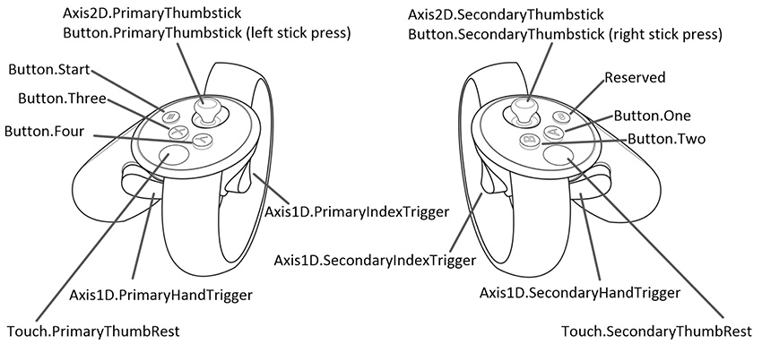

|  |  |  |  |  |
| --- | --- | --- | --- | --- |
| **Inputs** | **Interaction Type** | **Unity Button ID** | **Unity Axis ID** | **Axis Range** |
| Button.Three | Press | 2 |  |  |
| Button.One | Press | 0 |  |  |
| Button.PrimaryThumbstick | Press | 8 |  |  |
| Button.SecondaryThumbstick | Press | 9 |  |  |
| Button.PrimaryThumbstick | Touch | 16 |  |  |
| Button.SecondaryThumbstick | Touch | 17 |  |  |
| Axis2D.PrimaryThumbstick | Horizontal Movement |  | 1 | -1.0 to 1.0 |
| Axis2D.PrimaryThumbstick | Vertical Movement |  | 2 | -1.0 to 1.0 |
| Axis2D.SecondaryThumbstick | Horizontal Movement |  | 4 | -1.0 to 1.0 |
| Axis2D.SecondaryThumbstick | Vertical Movement |  | 5 | -1.0 to 1.0 |
| Axis1D.PrimaryIndexTrigger | Touch | 14 |  |  |
| Axis1D.SecondaryIndexTrigger | Touch | 15 |  |  |
| Axis1D.PrimaryIndexTrigger | Squeeze |  | 9 | 0.0 to 1.0 |
| Axis1D.SecondaryIndexTrigge | Squeeze |  | 10 | 0.0 to 1.0 |
| Axis1D.PrimaryHandTrigger | Squeeze |  | 11 | 0.0 to 1.0 |
| Axis1D.SecondaryHandTrigger | Squeeze |  | 12 | 0.0 to 1.0 |

|  |
| --- |
| *Open VR Controllers documentation is accessible here:* [*https://docs.unity3d.com/Manual/OpenVRControllers.html*](https://docs.unity3d.com/Manual/OpenVRControllers.html) |

### 

### 

### Our Commands: Inputs & Controls

|  |
| --- |
| ***Our Commands*** *list below is organized alphabetically.* |

### 

|  |  |
| --- | --- |
| **Action** | **Input** |
| **Activating/Deactivating Light Switches** | Collide controller into switch. |
| **Activating/Deactivating Shower Heads** | Grip shower handle (reacts to finger sensors) and turn controller. Release grip. |
| **Activating/Deactivating Water Faucet** | Collide controller downwards into flush lever. |
| **Dusting Objects with Duster** | Grip duster (reacts to finger sensors) and pass controller over desired areas. |
| **Flush Toilet** | Collide controller into toilet switch |
| **Gripping Objects** | Reacts to finger sensors. |
| **Locomotion: Travel** | To be determined / recorded. |
| **Locomotion: Turning** | To be determined / recorded. |
| **Opening Bags** | To be determined / recorded. |
| **Opening/Closing Sliding Doors, Lids, and Panels** | Grip (reacts to finger sensors) and move controller(s) in desired direction. Release grip. |
| **Opening/Closing Swinging Doors, Lids, and Panels** | Grip (reacts to finger sensors) and move controller(s) in desired direction. Release grip. |
| **Push Wristband button** | Point (reacts to finger sensors) and pass index into desired button. |
| **Pushing & Parking Cleaning Cart** | To be determined / recorded. |
| **Scrub Objects with Brush** | Grip brush (reacts to finger sensors) and pass controller over desired areas |
| **Squirting Spray Bottle Chemicals** | Axis1D.PrimaryIndexTrigger (left) OR  Axis1D.SecondaryIndexTrigger (right) |
| **Wiping Objects** | While gripping towel (reacts to finger sensors), pass controller over desired area. |

## Economy & Rewards System

Efficiently finish tasks marked on the active checklist to advance to the next room. Master the practice modules to graduate and exit your training session.

 To be further developed during Production.

## Game Options & Data

Game Options -- settings regarding difficulty, left-right-handedness, languages, user profiles, saved data -- are not currently intended to be added.

Height adjustments are intended to be incorporated. It is currently under research and development. Otherwise 5.5 is the average height for development testing.

 To be further developed during Production.

## Bonus Content: Secret Behaviors and Easter Eggs

|  |
| --- |
| *These are stretch goals. The content in this section are additional surprises that are to be considered for implementation only after all primary development tasks are done.* |

|  |  |
| --- | --- |
| **Secret Behavior & Easter Eggs** | **Special Response** |
| Insert utensils into power outlet | Confetti bursts from your face |
| Squirt spray bottle chemicals into your face | To be determined / recorded. |
| Drop objects into active garbage disposal | To be determined / recorded. |
| Using bleach and ammonia in the same room | To be determined / recorded. |
| Cleaning blender while it is active (on) | To be determined / recorded. |
| Place cart where it doesn’t belong | Receive a parking ticket |
| none (always present) | Framed artwork displaying student work |

# ► V. Game Art & Visual 3D Assets

## 3D Aesthetic

Realism is our goal. References have been provided in order to better produce assets as closely to the real things as possible.

## Reference Sources (Links)

See **Aesthetic References (pg29)**.

**Visual Samples:**

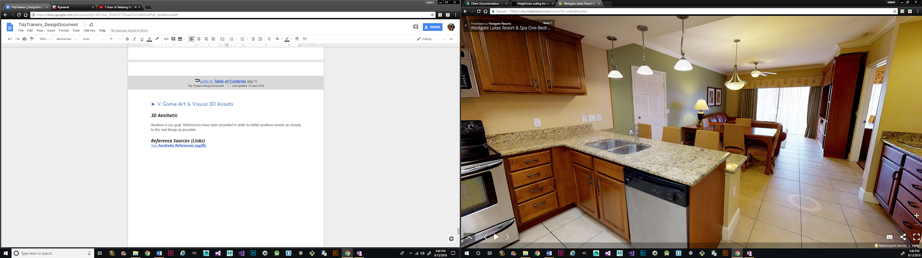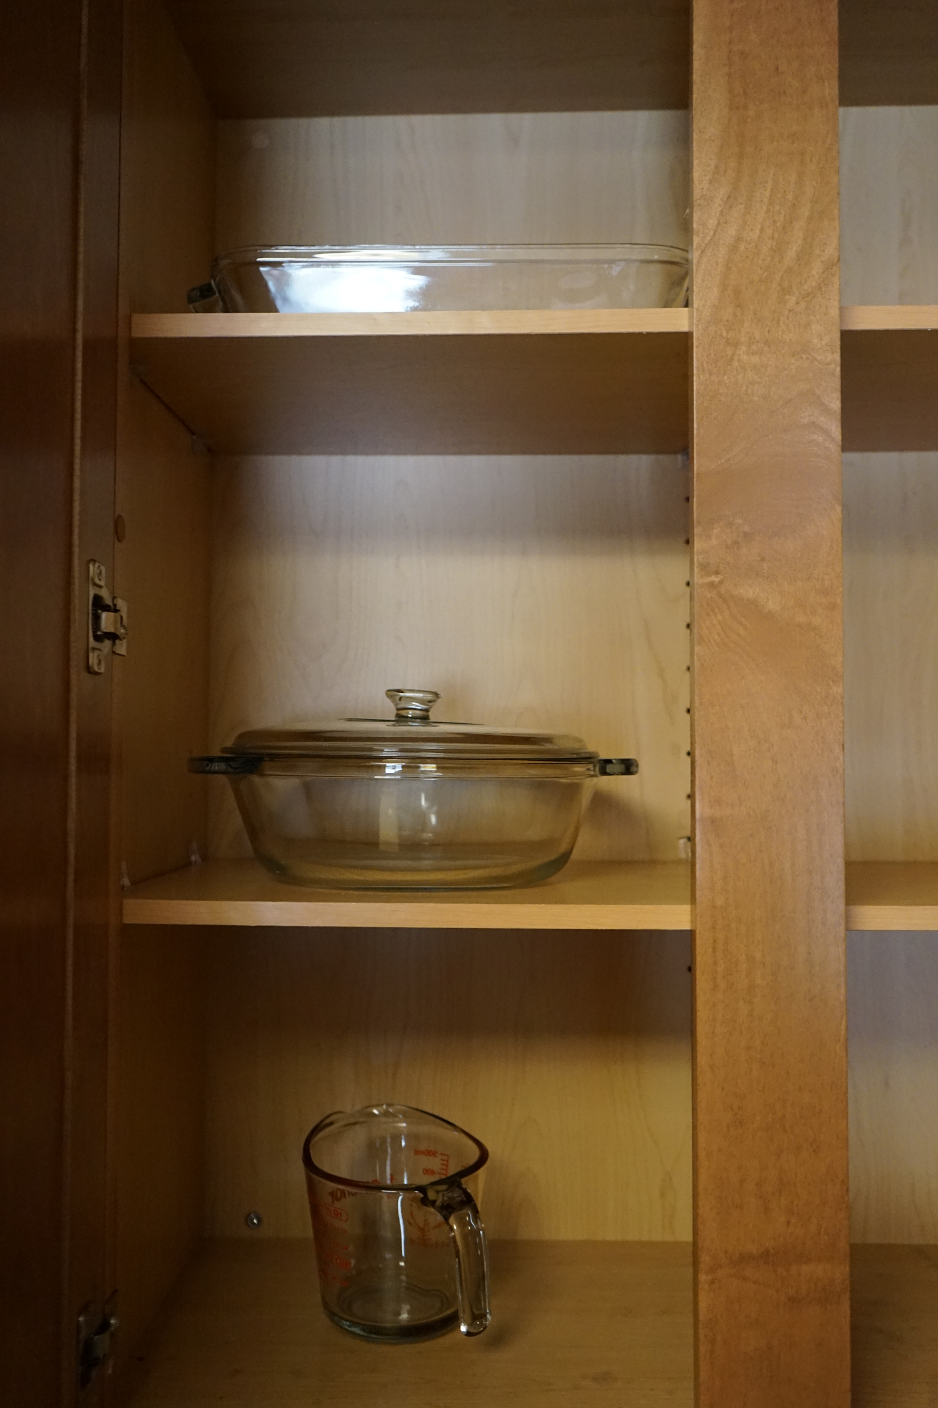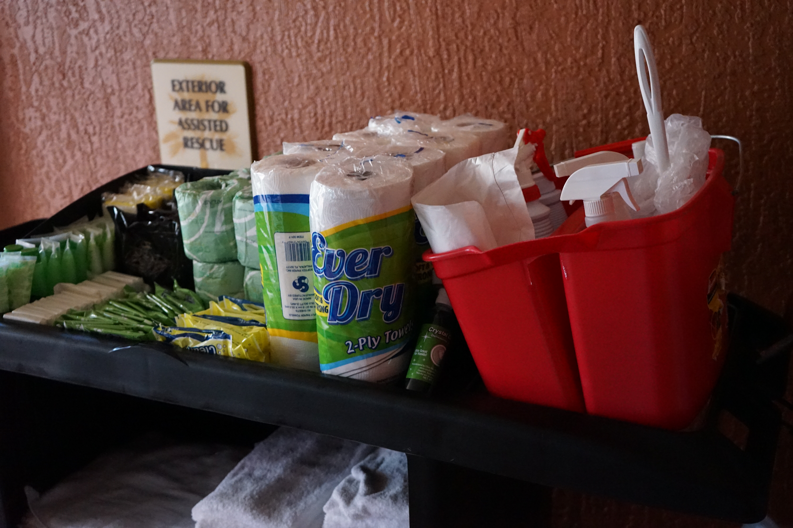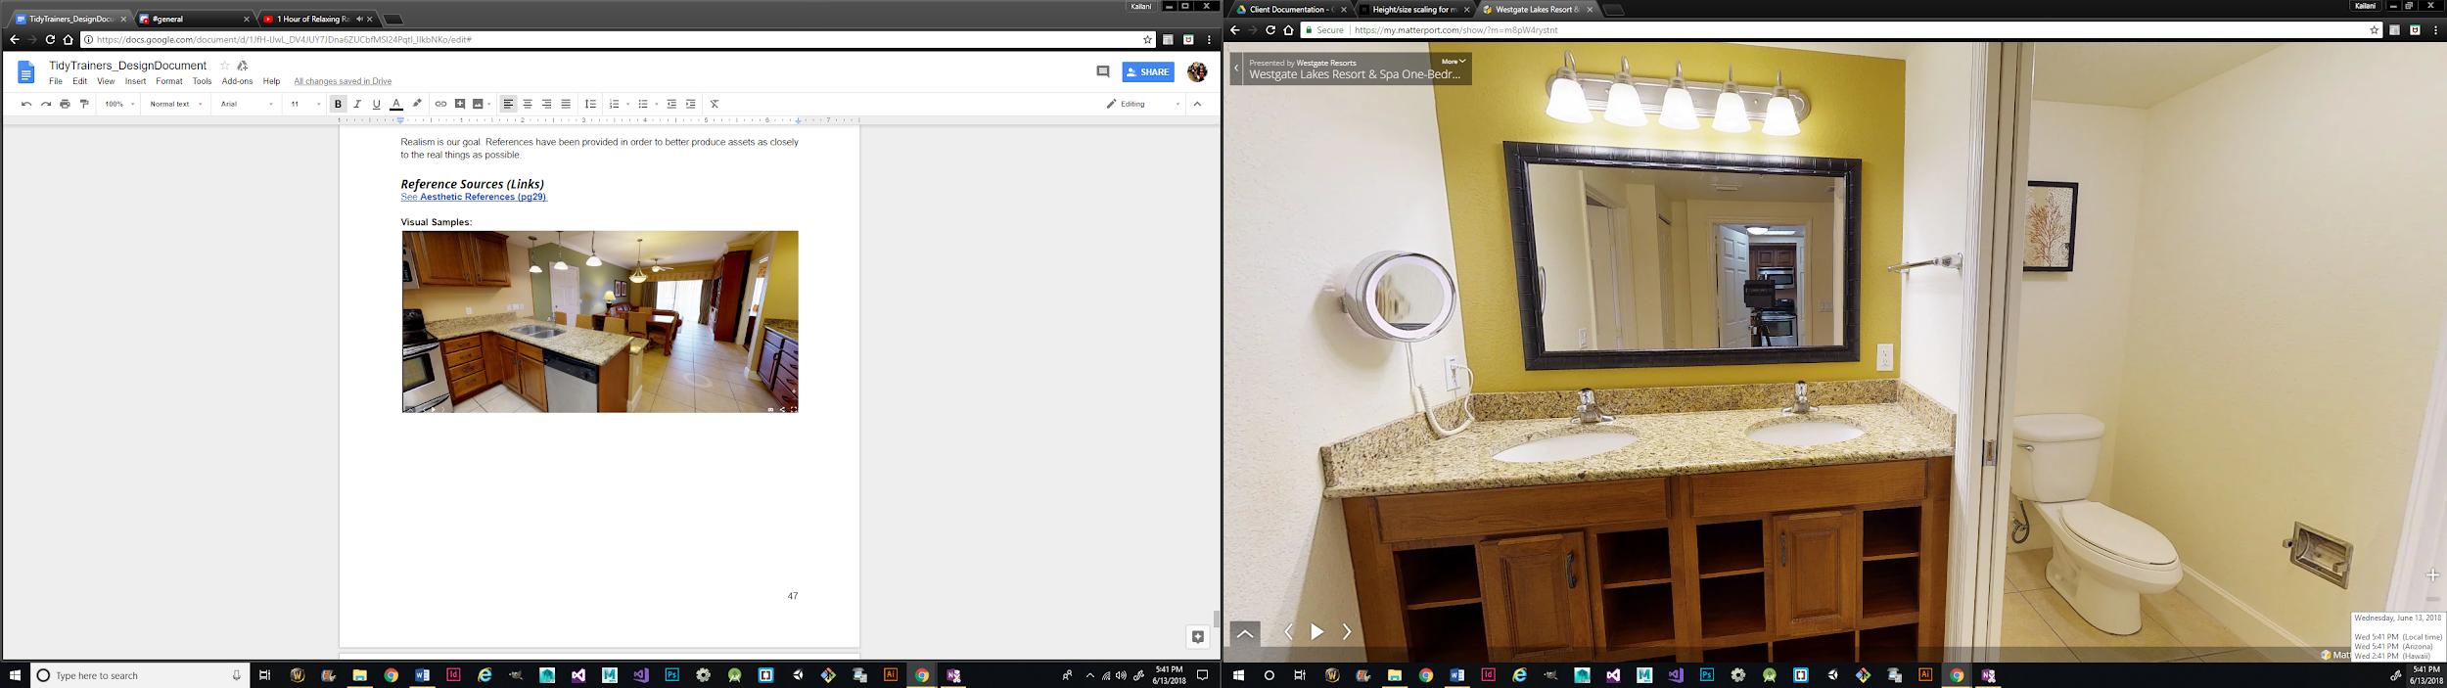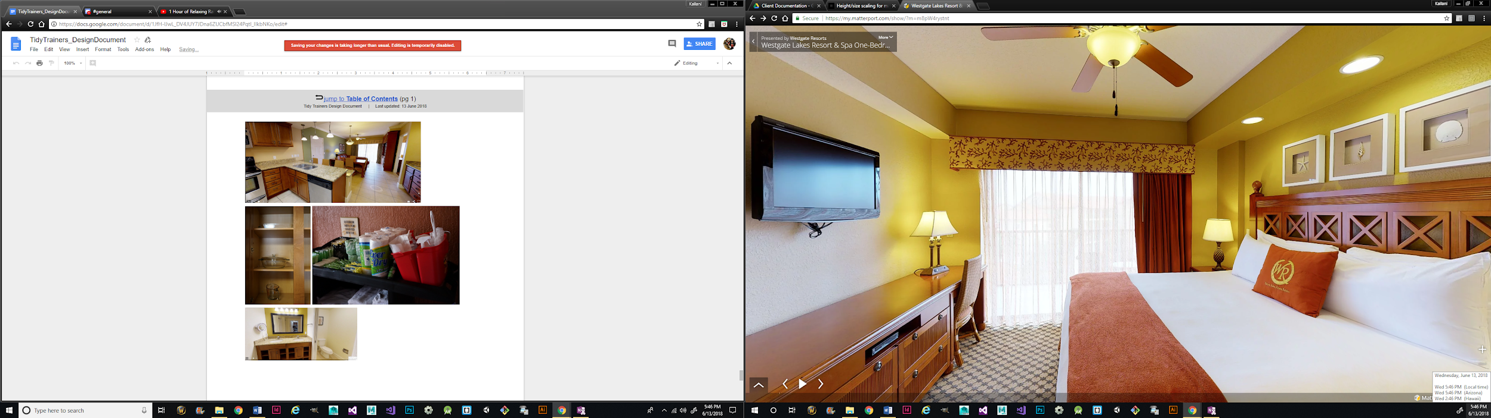

# ► VI. User Interface & User Experience

|  |
| --- |
| *Lightly discussed during Pre-production. To be discussed more in-depth during Production.* |

## UI Aesthetic

 Rounded icons are preferred. More to be discussed during Production.

## User Experience (UX)

 Intuitive buttons and readouts are the goal. More to be discussed during Production.

## Functionality

**Wristband:** Access menu items and simulation stats. Buttons and statistics include:

1. clipboard button: summons clipboard
2. checklist: access a visual to-do list
3. map: access a visual map
4. progression meters: view completion progress
5. assessment/efficiency readout: view task feedback

**Task Indication Bubbles:**

1. within proximity, indicates that an object is interactable (primarily for tutorial)

 More to be discussed during Production.

# 

# ► VII. Audio

|  |
| --- |
| *Lightly discussed during Pre-production. To be discussed more in-depth during Production.* |

## Sound Design & Intentions

The intention is to implement sound effects where they would naturally occur in the setting. For example: footsteps when navigating around the room, running water when the faucets are active, or wood against wood for doors, drawers, and other similar structures and objects.

## Sound Libraries & Resources

 To be updated during Production.



|  |
| --- |
| *This is the end of the design document.* |